Notes Lecture 1

**Fields format:**

[access_modifier][static][final] Type name[=init_val];

|  |  |  |
| --- | --- | --- |
|  | **Primitive types** | **Reference types** |
| **Stored** | on the *stack* | on the *heap* |
| **Passed** | By *value* | By *reference* |

**Overloading** =same name

**Overriding** = same signature

**Calling the superclass constructor:**

* It uses the keyword super.
* The call of the base class must be the first instruction of the subclass constructor

The keyword super

* It is used in the followings:
  + To call a constructor of the base class.
  + To refer to a member of the base class which has been redefined in the subclass:

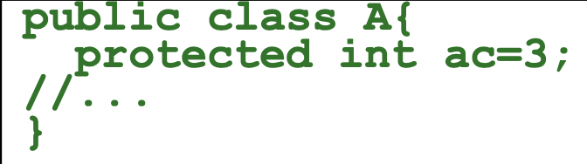

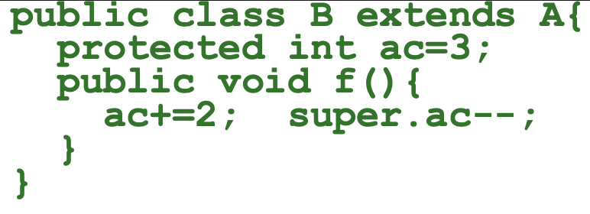

* + To call the overridden method (from the base class) from the overriding method (from the subclass)

